Wind Fences

Summary
- Effectiveness
  - 85% - industry estimate
  - 70-80% from a scientific paper (small-scale model)
  - Terrel Askew (from Coal Kills Baltimore) estimated 80% effective
- Lots of places currently use wind fences, for coal and other dust
- Lots of companies sell wind fences
- Policy: put around the coal piles in Newport News. Also around the dumpers in Norfolk?

____________________________________________________________________________

Current Use (for coal)
- Tianjin, China
- Jiangxi, China
- Murmansk, Russia (assuming construction completed)
- Latvia (assuming construction completed)
- British Columbia, Canada (WeatherSolve) - at a coal mine
- Northern Europe (WeatherSolve) – Latvia
- Oak Creek, WI
  - Email/call Oak Creek city planner
- Pueblo, CO (Comanche power plant)
- China (Hesley Group)
- WeatherSolve has 14 around just coal and several more around piles including coal and other materials
- Probably dozens or over 100 locations for coal and hundreds of locations including all wind fences

Current Use (non-coal or unknown)
- Middle East (steel pelletisation plant)
- Adelaide, Australia (cement plant)
- Canada, Oman, New Zealand (sawdust), Brazil, US (not sure if these were coal or not)
- Philippines
- Dandong Port

Proposed Use (for coal)
- Richmond, CA
  - I’m trying to get in touch with the No Coal in Richmond folks to ask about this
  - Settlement text
  - They currently have shipping containers set up as a windbreak, mandated after an earlier lawsuit. The current settlement mandates putting wind fences on top of the shipping containers. The wind fences are not yet up.
- Newport News, VA
- Australia

Companies
- A LOT of companies sell them
- ETW International WalMax, Green (Tianjin) Technology Development Company, Ltd.
  - Wind and dust suppression project for Mariveles in Philippines
  - Wind and dust suppression project for Coal Terminal in Tianjin Port
  - Wind and dust suppression project for Coal Storage Yard in Jiangxi Coal Reserve Center
  - Wind and dust suppression project for Second Phase of Dandong Port
- “Using Agglomerative Dust Suppression and Wind Breaks for Fugitive Dust Abatement”
  - By Dust Solutions Inc employees
  - “Open stockpiles are one of the largest sources of fugitive dust emissions (PM10 and PM2.5) in bulk material handling operations.”
  - “Wind erosion causes an estimated 30% of storage-pile fugitive dust emissions (Cowherd et al., 1974)”
  - “Vegetative cover, commonly used by agricultural facilities, is an effective and easy way to control wind erosion, however it requires significant maintenance. Artificial windbreaks were modeled after this idea to create a surface barrier that deflects a sufficient amount of the wind force to lower wind velocities to the leeward below the threshold to initiate particle movement from the pile (Billman et. al 1984). Wind fences are constructed of engineered fabrics that are stronger and less susceptible to damage from storms or maintenance.”
  - Has references from scientific journals and agencies
- “Environment and emissions, and dust control for the mining industry”
  - Wind fences for dust control
- Weathersolve (Canadian company)
  - Wind fences
  - 1/8 amount of dust (or more) (87.5% blocked, up to 90%?)
  - Fabric
    - Fence design
    - Types of fabric
      - (a) High Density polyethylene (HDPE) -good Ultra violet resistance good strength, good abrasion resistance, reasonable cost, good chemical resistance.
      - (b) Polypropylene – reasonable Ultra violet resistance, good strength, moderate abrasion resistance, low cost, good chemical resistance.
      - (c) Polyester – excellent Ultra violet resistance, high strength, good abrasion resistance, high cost, good chemical resistance.
      - (d) Nylon -, reasonable Ultra violet resistance, high strength, high cost, good abrasion resistance, reasonable chemical resistance, tends to stretch.
  - Works by decreasing wind speed rather than by catching dust; acts as a windbreak
  - Decrease wind speed by 50-80%
  - Can have a wind fence both upwind and downwind, prevent more dust
  - Used in Oman, Canada, US, Bahrain, New Zealand, Brazil (see downloaded PDF)
  - BTU loss – A study in Spain found coal pile mass loss 1% with the wind fence compared to 13% with the standard pile
  - Coal ports
    - Northern Europe - doesn’t say where specifically
    - 23m tall
    - “The port is currently operational and local monitoring stations downwind of the coal piles have reported that the dust fence has more than satisfied regulatory targets established by the port development program.”
    - Monitoring PM10 and PM2.5
    - Minimal maintenance
  - Pictures
- Wind Fencing | Dust Control Technologies, Inc
- Hesley Group
  - Somewhere in China:
  - 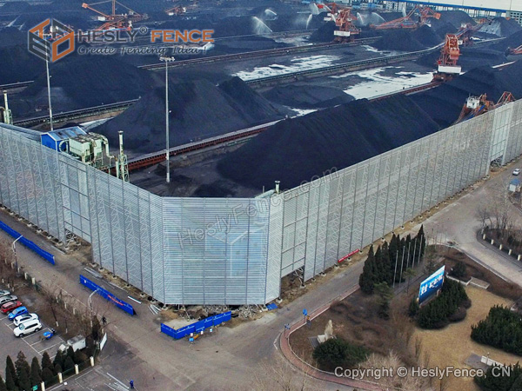
- Dust Solutions Inc (US company)
  - “Wind erosion causes an estimated 30% of storage pile dust emissions. Reducing wind speed equates to less dust.”
  - “DustTamer™ reduces dust emissions caused from wind erosion on open stockpiles. Our wind fence material is designed to exert a drag force on oncoming wind and reduce wind speeds up to 75% within the sheltered area. Our systems prevent dust that is generated by oncoming winds, material loading and unloading, and equipment and vehicle movement from becoming airborne.”
  - Diagrams showing how the wind fence works
  - They do CFD modeling for the project, to determine the best placement and size
  - “Our installation partners have installed millions of square feet of netting and wind fence material and have expertise in pole installation.”
  - Has info on the type of fabric and other specs
  - Also suggest wind fence use for unloading rail cars
  - COAL SHIPPING TERMINAL - Dust Solutions Inc. (nodust.com)
    - South Africa
    - “The client first looked at all areas that were using water sprays and found they were ineffective in providing efficient suppression.”
  - Article
    - “(DSI) makes a wind fence system—called the DustTamer—that is working well at many power plants, not only to reduce dust in the coal yard (Figure 3) but also to lessen wind speeds around hoppers, railcar unloaders, slag piles, ash ponds, gypsum piles, and landfills.”
    - 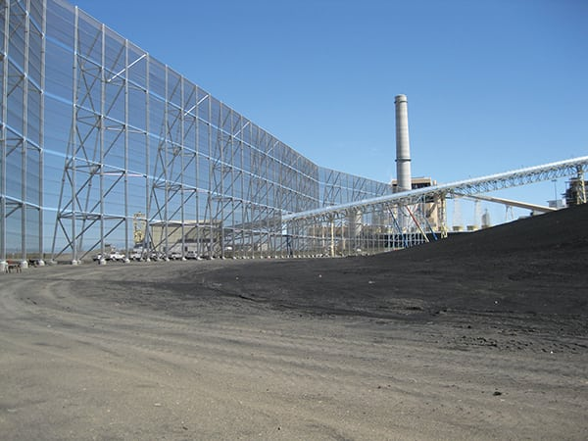
    - “This DustTamer fence is engineered to cut wind speeds at least in half. At 100-feet tall and 1,700-feet long, this example is the largest coal stockpile wind fence Dust Solutions Inc. (DSI) has constructed. Courtesy: DSI”
- WalMax (Chinese company)
  - “By installing our wind and dust controlling systems, you can achieve the following effects:
    - “Improving the surrounding environment of the coal yard and reduce the pollution of coal dust.
    - “Improving the working environment in the coal yard.
    - “Maximizing the number of suitable workdays in the coal yard.”
  - They also have wind fences for railways

Articles and websites

India
- “Let’s face it, coal is dirty”
  - India, 2023
  - “Water sprinkling is a universally accepted mitigation measure, but its effect is limited. Covering of coal piles and areas where the commodity is transported. Covering of rail cars is essential.”
  - “The port needs to now consider wind fences. A steel pelletisation plant in the Middle East built a 2.6 km long wind fence (20 mts high) to prevent pollution from its stockpiles. A cement plant in Adelaide, Australia, used the same solution.”
- “Air Quality Management in Mining Areas”
  - India, Ministry of Coal
  - Lots of water use
  - Also wind screens and trees to block

Richmond CA
- “RICHMOND COAL EXPORTS TO END BY 2026; EJ ADVOCATES CELEBRATE AGREEMENT”
  - “The ten mitigation measures included in the settlement require Levin to erect a canopy over the rail unloading facility conveyers and build wind fences around stockpiles. Levin will also add 140 additional water misters to further reduce dust. It will suspend operations when wind speeds reach 18 miles per hour — half the speed at which this is currently required. Wolverine, the Utah coal company that mines and ships the coal to Richmond, must add a dust control binding agent to the top of each rail car. This will enhance protection from “fugitive dust” on the open rail cars.”
- “Richmond City Council and Levin Terminal Reach Monumental Settlement to Phase Out Handling of Coal and Petcoke in the City By 2026”
  - Anna Stemmel - Earthjustice lawyer working on Richmond case
  - “Dust from coal and petcoke handling and storage contains fine particulate matter (PM2.5) and toxic heavy metals including arsenic, lead, and chromium that pose a serious health threat. Exposure to PM2.5 and heavy metals in particular is linked to cardiovascular and respiratory conditions including asthma, pneumonia, emphysema, heart disease, and cancer. There is no safe level of PM2.5 exposure.”
  - “Open transport systems will be enclosed, wind fences will be erected, and a total of 140 new misting dust-suppressors will be installed. While there may still be dust that escapes, these measures will make things better until the facility stops exporting and handling coal and petcoke in 2026.”
  - These articles from Nov 2021 - when are the mitigation measures required to be implemented?

Australia
- “BHP to Build Wind Fences in Port Hedland to Cut Iron Ore Dust”
  - “Australia’s first wind fences, designed to reduce dust emissions as part of Iron ore miner BHP’s AUD 300 million air quality”
  - 2022
- “BHP awards contract for Australian-first wind fences in Port Hedland”
  - 2022
  - First wind fences to be built in Australia for dust control
  - Expected to start Aug 2022 and take 14 months
  - 30m high fence, 2km long
  - Is it for coal?

Russia
- “The Murmansk Commercial Seaport seeks to fence in clouds of coal dust”
  - 2018
  - Exporting coal from Russia
  - “Local politicians have meanwhile petitioned Moscow to forbid the transfer of coal via Murmansk unless it is enclosed in something, instead of housing it in enormous heaps out in the open, but that has largely come to nothing.”
  - “Now, however, they have hit on something else – a method they say will reduce the amount of coal dust drifting into city air by as much as 90 percent: Enormous screens around the port to help trap the dust and keep it in.”
  - “…the screens were one of about 12 projects meant to improve the environmental impact of the Port, all of which are expected to cost around $44 million.”
  - “But he said the biggest immediate benefit would be offered by the screens, which he said will stretch some two kilometers and stand 20 meters high.”
- “Murmansk Port Hopes Huge Screens Will Trap Coal Dust”
  - 2019
  - “On Friday, Alexander Masko, the general director of the Murmansk Commercial Seaport, showed reporters 568 meters of the screens that the port has built thus far. He said the port had studied the experience of countries like Japan, China, Canada and Australia, which are themselves using fencing around ports that ship high volumes of coal.”
  - “The fences themselves aren’t impermeable. According to Sergei Pokrovsky, director of SMM, the company that developed the screens, they are designed to let wind pass through them, while trapping coal dust — essentially acting as an enormous filter.”
  - “Each of the screen panels, he said, are placed at a certain angle, which creates a vortex while the wind passes through them. Airborne coal dust then gets caught in that vortex and adheres to the screen before blowing into the city. From there, the port simply washes the screens from time to time.”

Oak Creek WI
- “We Energies to build large windscreen to combat coal dust issue in Oak Creek”
  - 2019
  - Has details about the size
  - “residents have complained about the issue and We Energies has enacted some measures to combat the coal, including planting about 200 trees and building up berms.”
  - “The city's plan commission unanimously approved plans”
  - City Planner Kari Papelbon
  - “Assistant Fire Chief Mike Kressuk said the fire department has a “significant concern” with the coal dust issue. He said this new structure is designed to solve the problem and the fire department doesn’t see any issues with it.”
  - Community members raised funds for their own air monitors in addition to the company’s monitoring
  - Whole construction project planned March-August
  - https://racinecountyeye.com/2020/01/24/oak-creek-neighbors-renew-coal-dust-concerns-after-fence-falls/ - Later article that residents were concerned about health effects after part of the fence fell
- “Clean Power Coalition Demands Better Air Monitoring from We Energies”
  - 2018, Sierra Club
  - Demands for better air monitoring
- “Public Notice on WE Energies’ Oak Creek Plant (Effective October 2019)”
  - 2019
  - Renewing WPDES permit
  - “24. Request for Runoff Monitoring: Commenters stated that deposited coal dust runs off into surface waters during rain events. One commenter requested that We Energies pay for testing of waters running off from slag sites, coal piles, fly ash, and unloading docks.
Response: Most stormwater runoff from the site is covered by an industrial stormwater general WPDES permit. Coal pile runoff and runoff from the limestone and gypsum area, however, are permitted under this individual WPDES permit, but only during a 10-year, 24-hour storm event. This permit prohibits discharge of coal pile runoff and runoff from the limestone and gypsum area except under a 10-year, 24-hour storm event. Under these weather events, the discharge is considered an emergency overflow and must be sampled prior to discharge via outfalls 008, 014 and 015, at which point it is subject to a 50 mg/L total suspended solids limitation. Any sampling required by this or the stormwater general permit will be paid for by the permittee. This comment seems to refer to runoff from areas of the site on which coal dust has blown from the pile and been deposited, rather than runoff from the limestone or gypsum areas. Such runoff would be covered under the Tier 2 Stormwater General WPDES Permit, which requires implementation of a stormwater pollution prevention plan to prevent stormwater from being contaminated.”
  - “32. Concern regarding Coal Dust: Coal dust from the facility blows off trucks and train cars and from the plant. This forms a black film on properties, beaches, surface waters, and swimming pools in the area.
Response: Coal dust is regulated by the department’s air management and stormwater programs. These comments are outside the scope of this permit, but they have been passed on to other programs at the DNR.”
- “WEC Energy Group plans to shut down Oak Creek coal plants by 2024”
  - 2020
- “Neighborhood near We Energies power plant bands together to improve air quality”
  - 2018
  - Community members used purple air sensors
  - “Last year, We Energies added a second coal pile to its Oak Creek power plant, 1,800 feet from a neighborhood. In spring, strong wind gusts blew coal dust into people's homes.”
  - “We Energies has its own air quality monitor on the south side of the plant and is installing another one on the near north side.
While data from those monitors is only released to residents once a month, a We Energies spokesperson says their monitors meet EPA standards. The filters can then be tested by an independent lab to determine where exactly the particles are coming from.
  - So far this summer, We Energies says no tests have come back showing coal.”
- “Coal Dust Controversy Spreads At Large Southeast Wisconsin Power Plant”
  - 2018
  - “They said the dust problem only got very bad last summer when the power company moved a coal pile closer to their home.”
  - “"It's in and on my air conditioner," Michelle Jeske said recently, while offering a brief tour of her back yard, pointing at objects thinly coated with black dust.”
  - “Metcalfe and other executives announced that Oak Creek employees will curtail or stop work on outdoor coal piles during windy days. They'll also lower the new coal pile and cover it with a temporary sealant.
The plant will also add an air monitor and possibly also build a new wind barrier.”
- “Study Confirms WE Energies Coal Dust On Oak Creek Homes”
  - 2018
  - “...results of independent testing that confirmed coal dust samples taken by the Environmental Accountability Group (EAG) and tested by Aspen Consulting, Inc.”
  - “There is no safe level of coal dust exposure.”
  - ““I used to live in Caledonia just south of the plant. Myself, my wife, and my children became very ill and after only eight years we had to move. We Energies did testing twice and said there wasn’t a problem, but when we hired someone to do independent testing, we found coal and fly ash in our house. I started EAG because it was clear that We Energies can’t be trusted with protecting our health,” said Bill Pringle, President of Environmental Accountability Group.”
  - There’s video of the press conference
  - “Aspen Consulting, Inc. was provided with samples of black residues collected on tape. One of the samples taken from a car and also the east side of an area home was examined through the use of electron microscopy and energy dispersive spectroscopy for analysis.
Reachers determined after testing that the morphology and elemental composition of these particulates are consistent with fine sub-bituminous coal dust.”
- “Test Results Confirm: Black Dust Covering Oak Creek was Toxic Coal from We Energies Plant”
  - 2018
  - ““This isn’t the first time this has happened. This is the first time they got caught. Coal dust blowing from the piles at these plants has been a problem for decades, and We Energies knows it. We want something done about it. We Energies won’t talk to us. The mayor won’t talk to us. We need help,” said Greg Millard a concerned local resident.”
- “Angry Oak Creek residents take complaints about coal dust to We Energies”
  - 2018
- “We Energies takes action after Oak Creek residents find coal dust, some neighbors say it's not enough”
  - 2018
  - “Crews are putting a hard crust over the pile to prevent coal dust from blowing to nearby homes.”
    - What is the hard crust made of?
- “EXAMINATION OF BLACK PARTICULATE RESIDUES FROM AN AUTOMOBILE LOCATED AT 4338 EAST STUDIO LANE, OAK CREEK, WI”
  - 2018
  - Test results
  - SEM imaging and elemental composition
  - “The morphology and elemental composition of these particulates are consistent with fine sub-bituminous coal dust.”
- WE Energies to build wind barrier to eliminate coal dust (tmj4.com)
  - 2019
  - $10 million
  - The company did testing and confirmed it was coal dust
  - Some doubt from residents on it working

Latvia
- “An impressive wind fence to prevent coal dust pollution is under construction on Krievu Island”
  - Latvia, 2018
  - “the main task of the wind fence will be to prevent the spread of coal dust in the surrounding environment”
  - Under construction already

Pueblo, CO
- Comanche's Coal Pile Wind Fence | American Galvanizers Association (galvanizeit.org)
  - Comanche power plant coal piles
  - 100ft tall, steel pipes, fabric-mesh fence
  - Has good pictures
  - 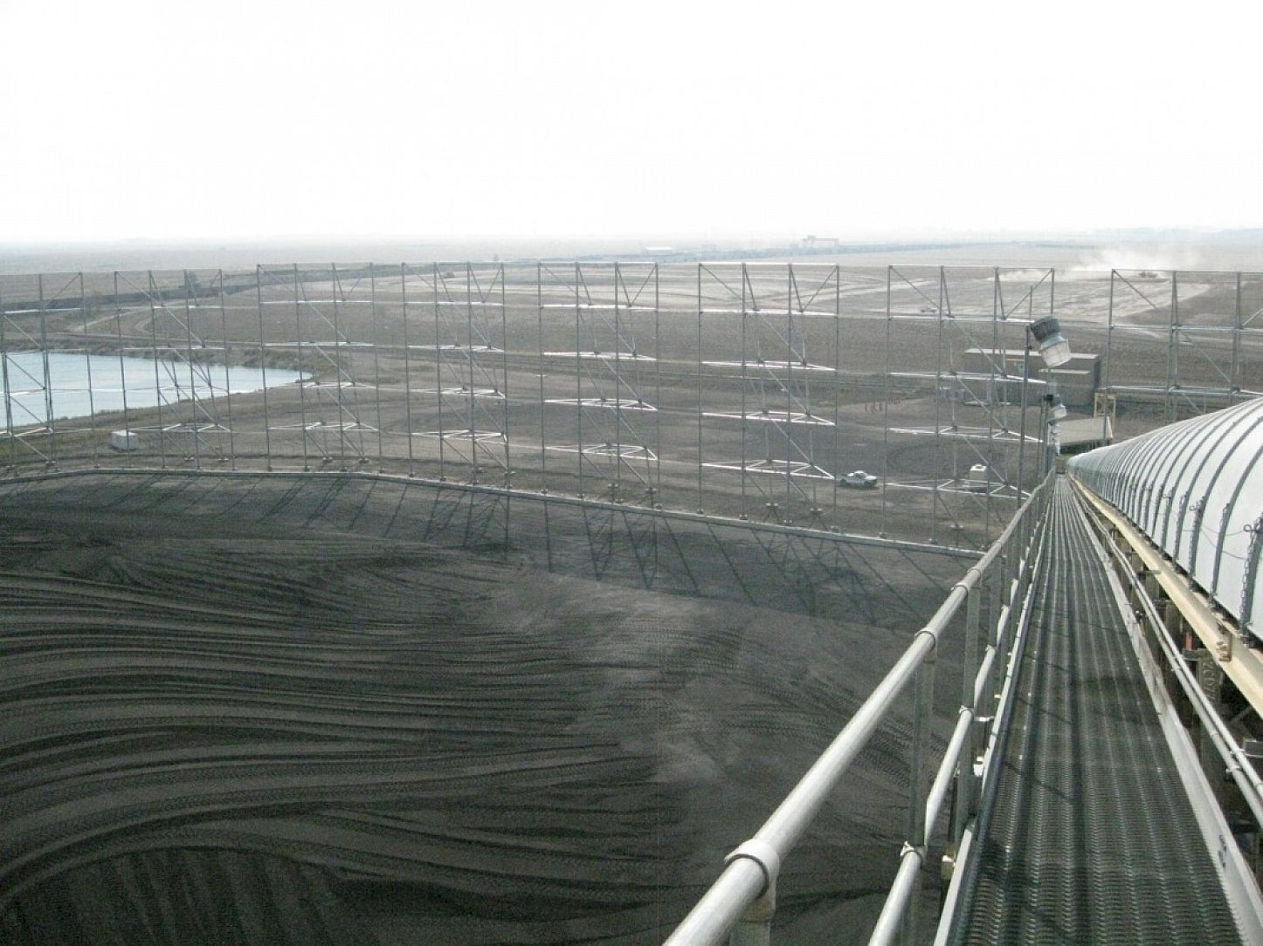

Other
- “Even when it’s sitting in storage, coal threatens human health”
  - The Conversation, 2017
  - “We found that wind blowing over uncovered coal piles at U.S. power plants plus gaseous emissions from the piles significantly increased concentrations of airborne fine particulates within 25 miles of these plants. Our findings suggest that this dimension of coal use should be regulated as well.”
    - The scientific study
  - 67% coal carried by trains, mostly uncovered; trucks and barges are typically uncovered too
  - “Though our analysis focused on areas around coal-fired power plants, people living near mines, rail lines or coal export terminals are also likely to experience increases in fine particulate pollution from coal storage and handling.”
  - “In contrast, there is no federal legislation explicitly targeting fine particulate emissions from coal storage and handling. However, since this air pollution is quite local, cities and counties can take action to mitigate it instead of relying on state or federal policy.”
- “Fugitive Dust Control Measures and Best Practices”
  - US EPA
  - “Storage Piles
    - “Monitor the moisture content and size of exposed material.
    - “Apply water or an approved chemical dust suppressant on a regular basis.
    - “Cover and stabilize or enclose material piles if not frequently accessed.
    - “Install wind breaks or barriers around the storage pile.”

Research studies
- “Wind tunnel testing of a coal pile model of the CVRD - Vitória, Brazil, and the effects caused by porous fences”
  - Loreda-Souza and Schettini, 2005
  - “Different fence porosities (68%, 53%, 37%, 0%) as well as different fence positions and heights were tested.”
  - “The fences with porosities ranging from 53% to 68% were most effective in reducing the pressure fluctuations on the windward face of the pile, without increasing significantly the mean pressures over it. These pressures are closely related to the dust emissions from the surface, directly affecting the surrounding environment. Although most effective for reducing pressure fluctuations, the best combined effect together with the drag surface velocities were found for the fences with intermediate porosities.”
  - Would be helpful to pull this paper from the UVA library to see if they report % decreases in dust emissions
- “The shelter effect of porous wind fences on coal piles in POSCO open storage yard”
  - Lee and Park, 2000
  - “a fence of porosity ε=40% was found to be effective for decreasing the mean pressure and pressure fluctuations on the coal piles. In addition, the wall shear stress on the windward surface decreased more than half of that for the no fence case. In order to get a good shelter effect for a large-scale open storage yard, the porous fence should be installed along all peripheral sides of the storage yard, and an additional middle fence is needed for every five consecutive piles to prevent the decreasing shelter effect from descending shear flow separated from the wind fence.”
- “Verification of the shelter effect of a windbreak on coal piles in the POSCO open storage yards at the Kwang-Yang works”
  - Lee and Park, 2002
  - “A porous wind fence of porosity ε=30% was found to be useful for reducing the wind speed without the formation of a recirculating bubble behind the fence. In addition, the fence caught the wind-borne particles when it was located behind the coal piles. The wind fence reduced the pressure fluctuations and surface shear stress on the coal piles to less than half of the levels observed in the no fence case. To verify the effectiveness of the porous wind fence installed around the Kwang-Yang open storage yard, the local wind speed and the concentration of suspended particles were measured directly. Full-scale porous fences installed around the Kwang-Yang open storage yard greatly decreased the turbulence intensity of the wind over the coal piles and reduced the total suspension particles by 70–80%.”
- “Windbreak Effectiveness For Storage-pile Fugitive-dust Control Wind Tunnel Study”
  - EPA 1985
  - 30% of pile dust emissions from wind erosion, 30% from loading in and out, 40% from vehicles (has a citation)
  - “Many states regulative fugitive-dust emissions by forbidding visible fugitive dust beyond the property”
  - Wind speed is the primary factor affecting particle uptake
  - Strong wind gusts are important, not just average wind speed
  - Has citations of other studies that have studied different wind breaks (different heights, porosities)
  - They said typical coal piles at electric plants at the time were ~11m high
  - They studied 50%, 65% porosity; and different distances from the coal pile; measured wind speed but not dust or PM
  - Graphs of where wind speed is decreased the most in comparison to the position of the windbreak
  - Windbreaks less than half the height of the coal pile don’t decrease wind speed much
  - Also a windbreak too far away isn’t useful
  - Windbreaks 1 or 1.5x the height of the pile decreased wind speeds 30-75%
  - Larger wind speed reductions with 50% porosity
  - How far away the windbreak is placed affects where the wind speed reduction is greatest - at the base/sides or top of the pile
  - Greatest wind speed reduction was windbreak 1.5x the height of the pile (compared to shorter) and 50% porosity (vs 65%)
  - Some nuances in whether the windbreak was better closer or farther from the pile
  - Windbreaks on top of the pile can also be locally effective in reducing wind speeds
  - Estimated efficiency (based on an equation) in relation to dust uptake
    - 39-99%
    - 99% is 1.5x height, 50% porosity, 1.5x length of pile, 3x the height away from the pile, with a conical pile
    - All windbreaks 50% porous at least as high and long as the pile were similar, and very good
    - I think the efficiency indicates the % of the surface area of the pile that would have no dust emissions
  - This was in a wind tunnel, so actually wind conditions will vary
- “HANDLE WITH CARE: THE LOCAL AIR POLLUTION COSTS OF COAL STORAGE.”
  - 2017, National Bureau of Economic Research
  - Concluded that uncovered coal piles increased PM2.5 concentrations at monitors up to 25 miles away
  - However, they analyzed 0-25mi as one group, so there's no breakdown of whether the PM2.5 was much higher at closer range, or whether the closer locations may be driving the trend for the group.
- “APPENDIX G Best Available Control Technology Analysis”
  - WI Power and Light commissioned
  - 2008
  - PM emissions from material handling - starts p2-122
  - List enclosures, fabric collectors, and wind fence among mitigation measures
  - South Heart Power Project
    - Wind fence for storage piles
    - Permitted, but not operating
    - This project (power plant) never happened
    - South Dakota
  - P2-125 has PM removal rates for different methods
    - Water spraying - 50%
    - Enclosure is listed as the best, but given no number
    - “The combination of surfactant, sealant, water sprayers and pile compaction is the top ranked control option for the coal storage piles because they are too large to be enclosed. There are no significant environmental, energy or economic impacts that preclude the use of these technologies for the coal storage piles. The combination of these technologies is selected as BACT for the coal piles.” = 90%
- “Control of Fugitive Dust Sources”
  - EPA, 1988
  - Storage piles p 4-1
  - Enclosures are good, but not generally used or studied
  - Wind fences are good
    - Can be man made or vegetative
    - ~50% porosity is usually good
    - Good for control of PM10
    - Low operating costs, low capital cost
    - Initial capital cost $12-61k (in 1980) (or $45-425 per tree)
  - P4-27 has a good list of technical details needed in a plan for a wind fence
    - Wind speed and direction
    - Physical dimensions of the coal piles and other equipment
    - Location of installation relative to prevailing winds
  - See p 4-44 for references
- “Experimental and numerical evaluation of wind-driven natural ventilation and dust suppression effects of coal sheds with porous gables”
  - Tianjin China
  - Su et al, 2020 preprint
  - They looked at covered and semi-covered coal sheds, also wind breaks
  - Open coal piles had the greatest dust emissions
  - The recommend the semi-covered coal shed (for ventilation) with wind breaks (for dust suppression)
  - It sounds like China does have some environmental regulations about coal dust pollution
- “Field measurements of shelter efficacy for installed wind fences in the open coal yard”
  - Cong et al, 2013
  - Qinghuangdao Port, China
  - Studied existing wind fence - put up in 2009
    - 40% porosity
  - 50% average wind reduction
  - “The results reveal that about 50–80% of total suspension particles are entrapped by the fence and the emission levels of the reference location satisfy the environmental regulations after the fences were installed along the yard boundary.”
- “Estimating fugitive particle emission from coal storage yard of thermal power plant using the flux-gradient method”
  - Kim et al, 2020
  - Korea
  - Measuring PM10 emissions, lot of info on that
  - More PM10 emissions during the day than night
  - “This study also provides useful recommendations for real-time monitoring and controlling PM10 emissions from coal storage sites.”
  - Pull the full PDF for the recommendations and stats on PM10 emissions
- Wind-Fence Efficiency Controling Particulate Matter Emissions from Coal Stockpiles in an Industrial Site | IEEE Conference Publication | IEEE Xplore
  - Soares et al 2021
  - Presented at a 2021 conference
  - Evaluation of the wind fence’s capacity to decrease PM emissions from a coal pile yard
  - Simulations from the wind directions that would hit the existing wind fence before the coal piles
  - They conclude that wind fences are good for mitigating PM emissions
  - Average efficiency 42% (13-59% depending on wind direction)
- WIND TUNNEL SIMULATIONS OF THE EFFECTS OF POROUS FENCE ON THE AERODYNAMICS OF MINERAL PILES
  - Pinheiro et al 2012
  - Scale model in a wind tunnel
  - Wind fence porosity 36% and 57% reduced wind speeds
  - The higher porosity fences were steel
- “3D numerical simulation of wind flow behind a new porous fence”
  - Chen et al 2012
  - Studying a deflector-porous fence (see the paper for a picture)
  - They conclude this new fence is better than a traditional wind fence
- “Experimental and numerical study of fence effects on dust emission into atmosphere from open storage piles”
  - Torno et al 2011
  - Porous fence reduces wind velocity
  - No velocity vortex with the porous fence (compared to the solid fence)
  - Porous fence reduces particle emissions by 78%
- “Three-dimensional modeling of fugitive dust dispersion in idealized openpit mines”
  - Bhowmick et al, 2015
  - Tracking where different particles go in an open pit mine
  - Winter inversion conditions kept most dust particles inside the mine
  - In summer conditions, most particles left the mine
- “Fugitive Dust Emissions from a Coal-, Iron Ore- and Hydrated Alumina Stockpile”
  - Topić and Žitnik, 2012
  - Background
    - “A wealth of epidemiological data support the hypothesis that on average, for every 10 ug/m3 rise of the total mass concentration of PM10 in the air there is an 1 % increase in cardiovascular mortality on a day-to-day basis (Routledge & Ayers, 2006).”
    - Chakraborty et al., (2002) for particle emissions rates from open air coal handling, Table 10
      - These authors say the numbers in Table 10 are similar to open air terminals
    - “Ferreira & Vaz, 2004). The experiments show that the use of covers reduces the amount of dust released by more than 80% compared to uncovered wagons.”
      - For trains, not piles
  - Experiment
    - “a portable Aethalometer (Magee Scientific, AE 42-2ER-P3) was used to measure coal dust”
      - It measures blackness of the particles; measures black carbon (coal dust)
    - Wind test track with samples of coal and other substances
    - Measurement the mass lost from samples of coal with different grain sizes
      - Minimal mass lost from coal with large grain size
      - 20-44% mass lost from the two samples with the smallest grain size
    - Threshold wind velocities (when the wind starts picking up PM10)
      - 5.6 m/s for the smallest grain size (12.5 mph)
      - 13 m/s for the next larger, and 14.8 m/s for the next larger (29 and 33 mph)
  - Look up their references
- Windbreak Effectiveness for Storage Pile Fugitive Dust Control: A Wind Tunnel Study
  - Stunder and Arya, 1988
  - Wind tunnel study
  - Looking at different parameters of wind fences – porosity, size, location
  - Estimated efficiency (depending on parameters of the fence): range 38-99%
    - Higher for a conical piles than an oval pile
    - My estimated values from the graph: 66, 66, 76, 76, 89, 90, 90, 91, 97, 98, 98, 99, 38, 45, 45, 50, 65, 69, 73, 74, 79, 80, 89, 95, 96
      - Average = 77.4% (1934/25)
    - They’re measuring wind speeds, not dust emissions, and then making assumptions based on the relationship between wind speed and dust uptake
- “Impact of the installation scenario of porous fences on wind-blown particle emission in open coal yards”
  - Cong et al, 2011
  - 85% for full enclosure, 55% for 2 sides wind fences, 65% for 3 sides wind fences
  - CFD modeling of coal stockpiles

Oak Creek, WI
- Milwaukee suburb
- On Lake Michigan
- At We Energies power plant
- There’s a small line of trees around some of the piles (2 rows deep)
- I think I can see the wind fence around ~50% of the north pile
  - S side, E side, and ⅓ of the N side
  - Doesn’t look like there’s any wind fence around the south pile
- Winds were from NW there when I checked
- You can also see coal on train cars, and there are no barriers around the rail lines
- Mostly non-residential around the plant
- Nearest neighborhood is 0.4 mi to the NW

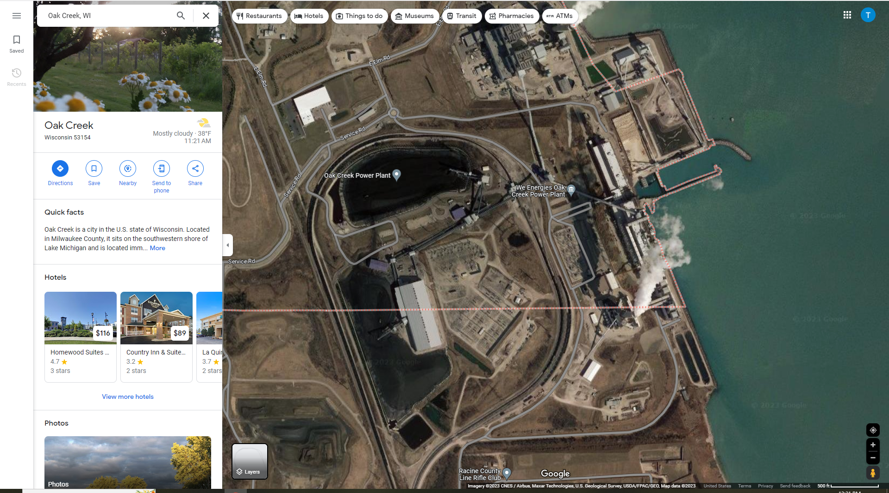
- MINUTES OF THE OAK CREEK PLAN COMMISSION MEETING TUESDAY, FEBRUARY 12, 2019
  - WE Energies part starts p3
  - Mentions 2 major companies – ask which?
  - Lots of questions answered about wind fences!
  - Resident: “Nobody consulted any of the residents here.” “The whole thing should have been covered.”
  - “Mayor Bukiewicz responded that the City doesn’t do this. It is up to the DNR and the EPA. The City of Oak Creek is not the governing agency for the dust.”
  - “Planner Papelbon responded that it would be the responsibility of WE Energies to communicate the effectiveness and how it is working with the residents. Mayor Bukiewicz added that WE Energies has information on their website that speaks to the issue of coal dust levels and what they are doing.”
- Email with Kari Papelbon, City Planner, May 23 2023
  - “Honestly, the City’s role in that was fairly limited – the Plan Commission is required to approve such applications at the WE Energies site. I’ve attached the minutes from the 2019 meeting to give you an idea of what nearby resident opinions were. WE Energies proposed the fences, and their engineers would likely have much more background on those fences than I (the issues surrounding the coal pile predate my time with the City).”
- Email with Kari Papelbon, May 24, 2023 (her responses to my questions in red)
  - “Why did WE Energies propose the fences? I’ve attached a copy of the letter they sent to neighbors explaining the project.
  - Was there any meeting after the fences were installed to review whether they were adequately mitigating the coal dust? Or other community forums where community members may have expressed if they were satisfied with the fences or not? I’m not sure whether WE Energies held any subsequent meetings of their own, but I do know that they monitor the fence for effectiveness and maintenance. I believe they experienced very strong winds and had to repair the screen a few years ago.
  - The minutes mention measuring the effectiveness of the fences. Was that done, and is the information available somewhere? Yes, but I would have to defer to WE Energies as the City has no oversight of the utility. Our expectation is that the fence is maintained.
  - The minutes mention monitoring. Is that monitoring of the wind speeds or air quality? Are those data available anywhere? Probably a bit of both, but I would have to defer to WE Energies for specifics.
- From the Feb 5, 2019 letter to community members in Oak Creek
  - Shared with me by Kari Papelbon

“Berms, trees and the wind barrier
Last year, 200 trees were added along with berms on the northwest corner of the property.
Please see the enclosed photo.

As we’ve mentioned before, our long-term strategy includes constructing a wind barrier to reduce wind velocity over the coal piles. We now have a design for the wind barrier to share with you.

The wind barrier will be made of green fence material and have a porous design that redirects and slows wind up to 95 percent. It will be 2,000 feet long and positioned along the coal pile closest to our neighbors to protect against winds coming out of the east, north and south. Its positioning also will reduce wind velocities to the other piles when winds are out of the east and north.

Our engineering studies show that the 100-foot-high wind barrier will not have much visibility from Haas Park because of the topography and new berm. The wind barrier will be most visible to the public from Fishing Pier Road as visitors travel to our fishing pier. Please see the enclosed renderings.

We are working with the City of Oak Creek to obtain the necessary permits. We anticipate starting construction this spring with completion by early fall.

We understand that as our neighbor, you may have questions about the wind barrier. We invite you to stop by the Oak Creek Community Center, 8580 S. Howell Ave., on Wednesday, Feb. 27, anytime between 3 and 7 p.m. to learn more.

Environmental
Results from the air monitor that began operation last summer show that the site continues to meet the Environmental Protection Agency’s ambient air quality standards. Data from the monitor is publicly available through our website – as is the data from the air monitor operating south of the site.

The Wisconsin Department of Natural Resources (WDNR) is reviewing the proposed reissuance of our Wisconsin Pollutant Discharge Elimination System (WPDES) permit. This permit sets limits for the site’s discharge cooling water and treated wastewater. The WDNR will conduct a public hearing on Monday, Feb. 11 at 1 p.m. at the Oak Creek Community Center. Written comments may be submitted to the WDNR through Feb. 18.

We will continue to keep you updated. If you have any questions or concerns about our operations at the Oak Creek site, please call us at 877-380-0522 during normal business hours or our 24-hour customer care line at 800-242-9137.

Sincerely,

Pat Stiff
Vice President”

Template for collecting information – Oak Creek

- Location: Oak Creek, WI, USA
- Facility name: Oak Creek Power Plant
- Company: WE Energies
- Type of facility: Power plant
- Surrounding area: Mostly farmland and residential neighborhoods
- Communities affected:
  - Neighborhoods: Oak Creek neighborhood northwest of the plant; Elm Road and Crestview neighborhoods
  - Demographics: I didn’t find stats for that specific neighborhood, but Oak Creek in general is majority white (~80%) and middle income (median household income ~$80k)
- Effectiveness at protecting waterways and air from pollution:
  - Was there air monitoring before?
    - Yes – by both the company (but there were community critiques of this monitoring) and by the community (Purple Air sensors and lab testing)
      - WE Energies said their monitoring was compliant with EPA standards and said they never detected coal dust when samples were sent for lab testing.
      - Independent lab testing arranged by community members confirmed that the dust was coal dust.
  - Is there air monitoring after?
    - Yes. I think both the company and community monitoring was maintained for some time, but I’m not sure how long. (No Purple Air monitors in that area are currently on the Purple Air map.)
  - Did air quality improve after?
    - Uncertain. I haven’t been able to find any of the monitoring data.
  - Was dust visible on surfaces before?
    - Yes. News articles and public comments cite dust on properties, homes, backyard furniture, beaches, surface waters, swimming pools, and more.
  - Is dust visible on surfaces after?
    - Uncertain. A news article reported community concern when the fence fell, which indicates that the fence was probably mitigating some amount of fugitive dust.
  - Were there community complaints before?
    - Yes.
  - Are there community complaints now?
    - Yes. There were complaints when the fence fell. And residents still said they wanted the coal pile gone.
  - Are there any complaints about the fence?
    - High winds during a storm knocked down the fence.
  - Is the community satisfied with the dust reduction and current air quality?
    - Not completely. Residents said they wanted the coal pile gone. Some people expressed wanting to move away. A news article reported community concern when the fence fell, which indicates that the fence was probably mitigating some amount of fugitive dust.
  - Was there water monitoring before?
    - Limited water monitoring. A public comment on a permit review said that coal dust runs off into surface waters when it rains. The response said the runoff was allowed under the stormwater permit, but only during a 10-year, 24-hour storm event, during which water sampling would be required at 3 locations (50 mg/L total suspended solids limitation).
  - Is there water monitoring now?
    - Same answer, I think.
- Technical specifications:
  - Manufacturer: NA
  - Height of fence: 100 ft
  - Length of fence: 2,000 ft
  - Porosity of fence: 50%
  - Material(s) of fence: fabric, green tint
  - Distance from fence to dust source: NA
  - Position of fence relative to dust source (ex: N, S, E, W): south and east sides
  - Predominant wind direction: southeast? (or that’s when the dust blows into the neighborhood)
  - Size and dimensions of dust source(s):
    - Number of piles: 2
    - Height of coal piles: 85 ft
    - Total area that the piles cover: NA
- Cost: NA
- Installation:
  - Permits needed: building permits, Oak Creek Plan Commission approval, maybe others
  - Amount of time: Expected 6 months, March to August
- Policy and advocacy:
  - Relevant regulatory agency(ies). Who has authority to regulate?
    - The WI Department of Natural Resources’s air management and stormwater programs
    - EPA
  - Who proposed the wind fence?
    - WE Energies
  - What actions led to approval?
    - Community complaints
    - Community air monitoring
    - Community testing to confirm the dust is coal dust
- Any other relevant notes or information:
  - The dust situation worsened when a new pile was placed closer to the neighborhood.
  - The power plant is slated to be shut down by 2024

WeatherSolve Info

Email from Mike Robinson, June 12
- “Glad to hear that the people of Newport News are still pushing for a solution.
The reporter talked to me prior to writing his article.

The coal yard location is in a difficult location with respect to not spreading dust over the city.
With a prevailing SW wind then a 30m high fence where the blue line is below would minimise the dust getting lifted into the air from about half of the yard.
The yellow line at the NE side would act as a collection mechanism for the dust still moving.
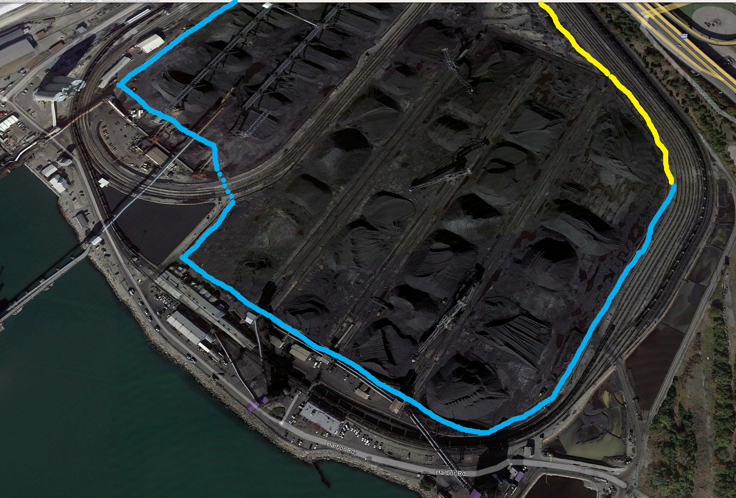

The way to prove the potential efficacy of the system is to get a CFD study done.
Do you have a CFD unit at U Virginia?
We usually use the Midwest Research Institute or RWDI.
MRI in particular may fit your project as two of the projects they have done CFD studies on have back-up results in the form of before and after measurements.

One was Vale in Vittoria, Brazil. MRI calculated 78% effectiveness and the actual measured result was 74%. (The measurements were set up, measured, and analysed by Vale).
The other was Hadeed in Saudi Arabia. There the calculated was 84% and the actual was 90%. (WSS did the set up in that case, measurements by Hadeed, and analysis by WSS).

I have attached our typical blurb for CFD studies.

In terms of costs, finished prices are dependent on many variables- including the level of control deemed acceptable. Most of our customers target around 80% as a reasonable number.

We supply some engineering plus the cladding system. Local suppliers and designers supply the rest.
In this case the project will certainly exceed USD$20 million and might be closer to $30m.

If you have CFD resources, then you may be able to get the CFD done reasonably economically. If WSS + MRI does it then the costs are likely to be around USD$80,000 +/- depending on how much electronic data is available to build the model from.

Let me know what works for you and we will help as appropriate.”

Email from Mike Robinson, June 13
- “I'd say 3/4 of wind fences built are at least partially motivated by some sort of environmental regulation or pressure.
Others are conscious of the loss of material in a wind and/or the loss of BTU value (for coal storage). I have attached a paper summary that covers that aspect.
Dust that ends up on the cars of the executives, on intakes for air coolers and on electrical facilities are also all significant motivators.

Regarding other fences in the US, yes, we have several although the uptake in the US is lower than many places.
Not sure about the WI one - if it is one of ours I don't recognize it by that name.”

Email from Mike Robinson, June 13
- “Here is the paper.

The two studies were both on steel pellet piles. Denser than coal of course- though on the flip side, coal has less fines as a percentage and the larger lumps form a sort of protected coating over the piles (until something drives over it, digs it, or a really strong storm opens up the surface.)
For coal piles, we have fences around piles in Vittoria x 2 and Imbituba (all Brazil), Egypt x3, Canada x3, Latvia, about 4 in the US plus several more that are around groups of material which include coal.

The WE one was a project that we bid on unsuccessfully. Our systems are set up for pole spacings up to 150ft (100ft is common). It makes the poles economical and easier to dodge underground utilities, railway tracks etc but they are bigger poles and WE decided to go with a system that uses lots of skinny poles.”

- WeatherSolve wind fence locations
  - “Vittoria x 2 and Imbituba (all Brazil), Egypt x3, Canada x3, Latvia, about 4 in the US plus several more that are around groups of material which include coal.”
    - He also mentioned one in Saudi Arabia
    - 15 just coal, plus “several more” that include coal
      - Under the assumption that “a few” is 3 and “several” is at least 4, I’m calling this estimate minimum 19, and possibly more
  - Articles about Vitoria, Brazil
    - Wind-Fence Efficiency Controling Particulate Matter Emissions from Coal Stockpiles in an Industrial Site | IEEE Conference Publication | IEEE Xplore
      - Presented at a 2021 conference
      - Evaluation of the wind fence’s capacity to decrease PM emissions from a coal pile yard
      - Simulations from the wind directions that would hit the existing wind fence before the coal piles
      - They conclude that wind fences are good for mitigating PM emissions
      - Average efficiency 42% (13-59% depending on wind direction)
    - WIND TUNNEL SIMULATIONS OF THE EFFECTS OF POROUS FENCE
ON THE AERODYNAMICS OF MINERAL PILES
      - Scale model in a wind tunnel
      - Wind fence porosity 36% and 57% reduced wind speeds
      - The higher porosity fences were steel
    - Industrial Park, Vitoria
      - You can see the wind fence around the coal piles on google
      - 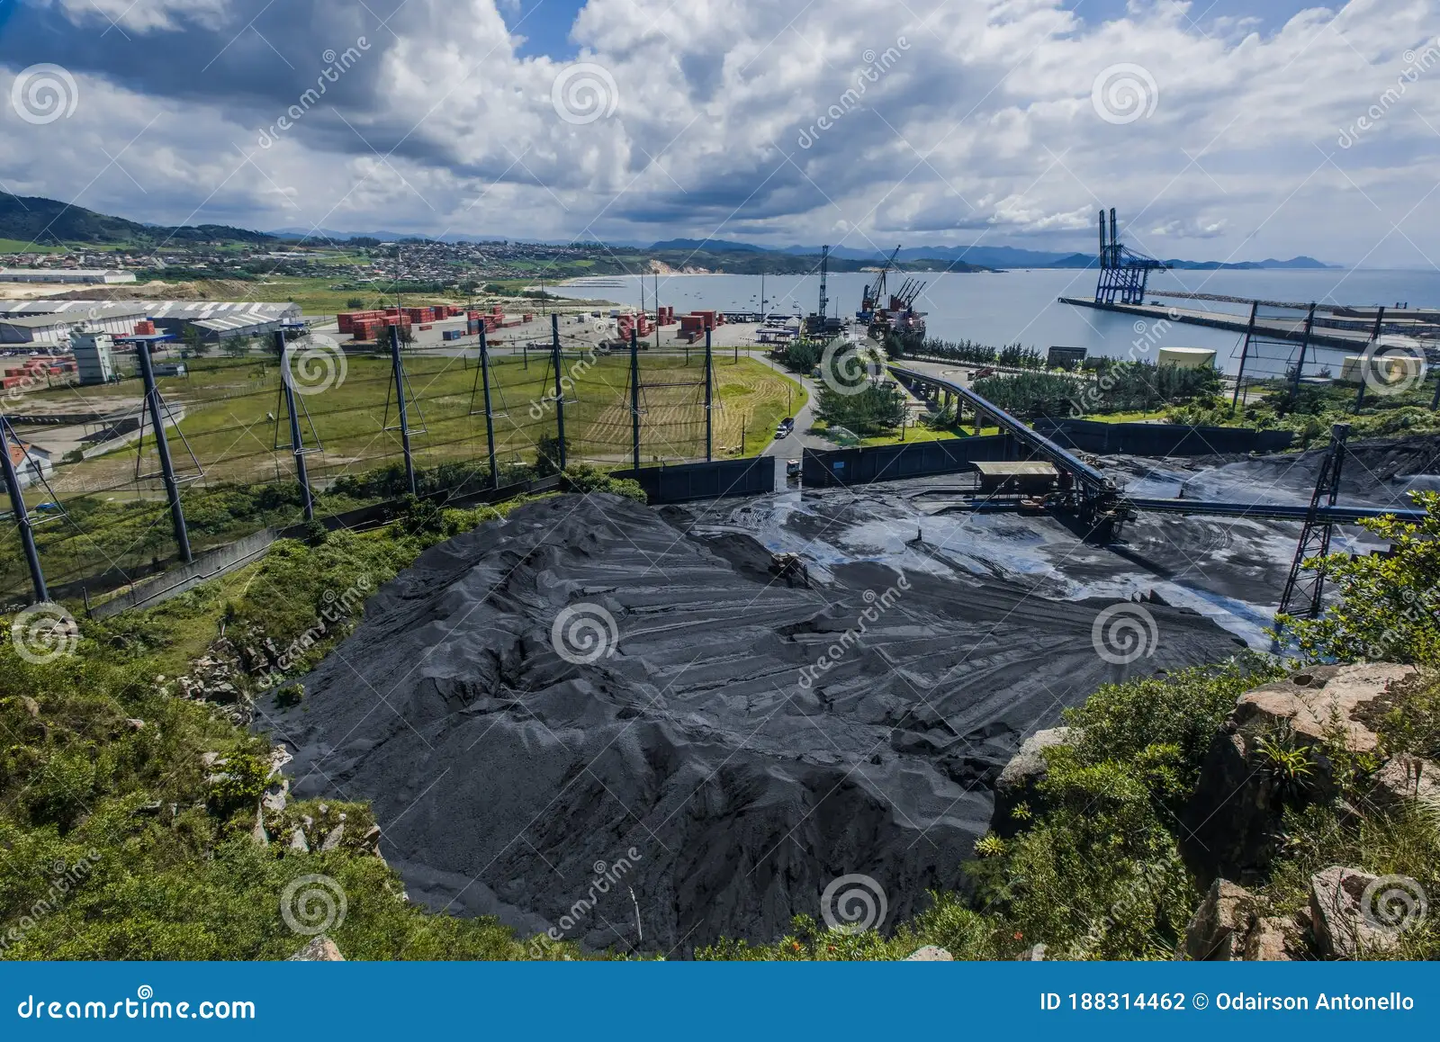
- Coal Dust Solutions for the Mining Industry - (ventsmagazine.com)
  - WeatherSolve wind fence picture (doesn’t say where) -> Imbituba
  - 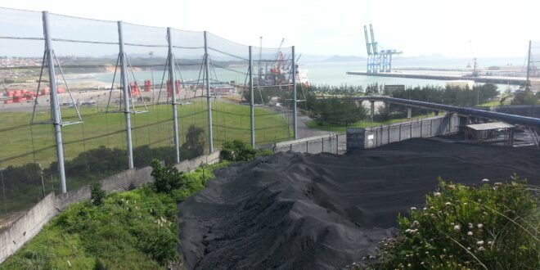

Dust Solutions Inc Info
- Email from Richard Posner, 6/30
  - “Dear Tara,
We received your email through our website. I wanted to hopefully address some of your questions. We have discussed at this place in the past, but they always balk at the price because it does not specifically add to the bottom line of the client:
Hello, my name is Tara. I work with a research group at the University of Virginia, and we're currently working with community advocates to explore solutions to coal dust pollution from coal piles at a terminal in Newport News, Virginia.
We are gathering information to demonstrate that a wind fence is needed and would be effective for coal dust mitigation in Newport News. We would greatly appreciate any information you are able to share with us about existing wind fence use and research, particularly:
1) research supporting the use and effectiveness of wind fences,
Absolutely. There are many papers written on this, but one of the most respected is attached here in the Journal for Air Pollution Control. This was written around our wind fences and specifically coal stockpiles.

2) examples and details about current wind fence use around coal piles,
Attached are some examples of fences we have done around coal piles. Specifically the Xcel Energy plant we installed a 100’ tall wind fence. They had monitoring around the fence for PM2.5 and PM10. Subsequent to installing the fence they had no high dust alarms. I have attached that article as well.
3) any documentation of the effectiveness for dust mitigation in surrounding communities (eg, before and after comparisons of air monitoring, community complaints or testimonies, pictures showing dust, etc.), and
As above. I have also attached one we did around a coal plant in Czech Republic with some monitoring as well. We are currently installing a large fence around a coal pile at a port in Superior Wisconsin as well, as we speak. We have done ones in Russia, SE Asia, China, India, and countries around the world. Also, a 80’ tall one is being installed in Brazil by us right now as well.
4) average cost and installation time for projects (rough estimates are still helpful).
This is ALL over the map and depends on height, length, soil conditions, porosity of the fence. Small ones have been around $100,000 turnkey and one of our largest was Wisconsin Energy 100’ tall around their coal piles that was upwards of $6.5million turnkey. Few photos of this one attached.
Anything else we can help with please let me know.”

- He confirmed that the Wisconsin Energy one is in Oak Creek, WI
- He confirmed the air quality study data that he attached was from the Czech Republic location
  - Wind speed dropped by 70%
  - They measured dust emissions from 2 “tray charcoal” sources
  - They measured PM 2.5 and PM10
    - The % decrease was the exact same for both which is weird
  - Average decrease in PM of 84.58% (77.5 and 92.3%)
- I emailed 4/24 to ask about continuing operations during construction/installation
  - Tara 4/24: “Are facility operations able to continue as usual during construction/installation?”
  - Richard 4/24: “Absolutely. Most of our clients cannot shut down production during our install and construction of the fences.”
- Examples of wind fences around coal piles
  - Slideshow includes some non-coal
  - Really good pictures
  - Coal or petcoke (n=10):
    - Xcel Energy Comanche Station, Colorado
      - Power plant
      - 30m/100ft tall and 520m/1700’ long
    - Amfire Mining, PA
      - 12m/40ft tall and 305m/1000’ long
      - Coal mining
    - Premcor (Valero), DE
      - Petcoke
      - 9.1m/30ft tall and 229m/750’ long
    - Deer Run Mine, IL
      - Coal mine
      - 21m/70ft tall and 305m/1000’ long
    - Suez Cement, Egypt
      - Coal pile
      - 7m/23ft tall and 440m/1443’ long
    - TXU Sandow, TX
      - Power plant
      - 12m/40ft tall and 219m/720’ long
    - Titan Cement, Beni Suef, Egypt
      - Petcoke
      - 13m/42ft tall and 304m/1000’
    - SD-Bilina, Czech Republic
      - Coal mine
      - 13.5m tall and 337.6m long
    - Wisconsin Energy, Oak Creek WI
      - Power plant
      - 30m/100ft tall and 800m/2500’ long
    - Oteko Taman Russia
      - Dry bulk terminal, coal export
      - 30m/100ft tall and 3500m/11482’ long
- Cost: $100k to 6.5 million (I think we’d be on the more expensive end of that)
  - An article said the WE Energies one (Oak Creek) was $10 million
- An article about their wind fence at Comanche (Colorado)
  - 10-story tall wind fence
  - No high-emission events (dust) recorded since installation
    - How many/how frequent before? -> doesn’t say
    - They did have some events before
  - 8 million tons of coal per year
  - 10 acres
  - Cost $4 million
  - The fence is supposed to last 20 years
  - Fence is upwind; reduces wind speed by 50%
- See Excel spreadsheet for all their installations
  - 978 installations on there
  - Coal or petcoke – 68 w/o repeats; 80 with repeats
    - ** Are the repeats new wind fences or expansions or repairs?
    - Coal if not specified
    - First Energy, EastLake Plant, OH
    - Thompson River Cogeneration Plant, MT
    - Kennecott Energy Cordero Rojo, WY
    - AEP Mitchell Station, WV
    - Premcor (petcoke), DE
    - Premcor (petcoke), DE (again)
    - American Electric Power - Cardinal Station, OH
    - TXU Generation Company LP, TX
      - Luminant is under TXU
      - Includes Sandow, Oak Grove, and maybe 9 other coal-fired power plants
      - I’m only going to count one of the TXUs
    - Emcor Cacesa Centro de Carga, Spain
    - Dominion - Brayton Point Station, MA
    - NB Power Generation - Belledune Generation Station, Canada, NB
    - Brayton Point, MA
    - Luminant - Reddinger, TX
      - Not sure if this is the same or different from the Luminant below; I’m leaving them both for now
    - AES Hawaii, HI
    - Bunge, LA
    - Canadian Gas & Electric, Canada, AB
    - Calstock Power Plant, Canada, ON
    - Xcel Energy - Comanche, CO
    - Luminant Mining, TX
      - Maybe Kosse Mine
      - There’s also Oak Hill coal mine at Martin Lake
    - Aurora Energy, USA, AS
    - Xcel Comanche Station, CO
    - Prairie Mines, Canada, ON
    - Amfire, PA
    - Westar Energy, KS
    - Deer Run Mine, IL
    - PBS Coals, PA
    - Suez Cement, Egypt
    - Duke Belews Creek, NC
    - AES Tamuin (petcoke), Mexico
    - Colstrip Talen Energy, MT
    - Expera Papers, WI
      - Mosinee WI, confirm it does look like there’s coal there
    - Lafarge Cement, Egypt
    - Safi Power Plant Project, Morocco
    - Manitowoc Public Utilities (petcoke), WI
    - Titan Cement, Egypt
    - CSX Curtis Bay, MD
    - Taman Bulk Terminal, Russia
    - Lafarge Cement, Egypt
    - El Sewedy, Egypt
    - Talen Energy, MT
    - Western Fuels, WY
    - Riga Coal Terminal/Strek, Latvia
    - Talen Energy, MT
    - Corsa Coal Acosta Mine, PA
    - Riga Central Terminal, Latvia
    - Oteko Taman, Russia
    - Kalningrad, Russia
    - Teck Line Creek, Canada, BC
    - Haixi Heavy Duty Machinery, China
    - River Trading Refined Coal, TX
    - Xcel Energy
    - Primzavod, Russia
    - Bronco Mines, NV
    - Teck Line Creek, Canada, BC
    - ExxonMobile (petcoke), Belgium
    - Nesher, Israel
    - Exxon Antwerp (petcoke), Belgium
    - Aditya Birla, India
    - Dubai Ports World (coal and petcoke), Egypt
    - Consumers Energy Karn, MI
    - AES Puerto Rico, PR
    - Arcelor Mittal Tubarao, Brazil
    - Vale Vitoria, Brazil
    - Nesher, Israel
    - Consumers Energy, MI
    - AEP Mountaineer, WV
    - JSW Steel, India
    - Vedanta Resources, India
    - Graymont Materials, WI
    - Arabian Cement, Egypt
  - Other wind fences (grain, dry clay, clinker, paper, gypsum, limestone, construction, copper/nickel, nitrate, soda ash, bauxite, gold, solar, steel)
    - 110
  - They do other dust mitigation as well (fogging systems, etc)

Template for collecting information
From places that currently use wind fences

- Location:
- Facility name:
- Type of facility:
  - Ex: coal mine, coal terminal, construction, other
- Surrounding area:
  - Ex: industrial, residential, urban, rural, mix
- Communities affected:
  - Neighborhoods:
  - Demographics:
- Effectiveness at protecting waterways and air from pollution:
  - Was there air monitoring before?
  - Is there air monitoring after?
  - Did air quality improve after?
  - Was dust visible on surfaces before?
  - Is dust visible on surfaces after?
  - Were there community complaints before?
  - Are there community complaints now?
  - Are there any complaints about the fence?
    - Eyesore? Barrier to other commerce? Problems with it?
  - Is the community satisfied with the dust reduction and current air quality?
  - Was there water monitoring before?
  - Is there water monitoring now?
  - (For all of these, include any quantitative or qualitative metrics available and information on the method and equipment used for monitoring)
- Technical specifications:
  - Manufacturer:
  - Height of fence:
  - Length of fence:
  - Porosity of fence:
  - Material(s) of fence:
  - Distance from fence to dust source:
  - Position of fence relative to dust source (ex: N, S, E, W):
  - Predominant wind direction:
  - Size and dimensions of dust source(s):
    - Number of piles:
    - Total area that the piles cover:
- Cost:
- Installation:
  - Permits needed:
  - Amount of time:
- Policy and advocacy:
  - Relevant regulatory agency(ies)
    - Who has authority to regulate?
  - Who proposed the wind fence?
  - What actions led to approval?
- Any other relevant notes or information:

